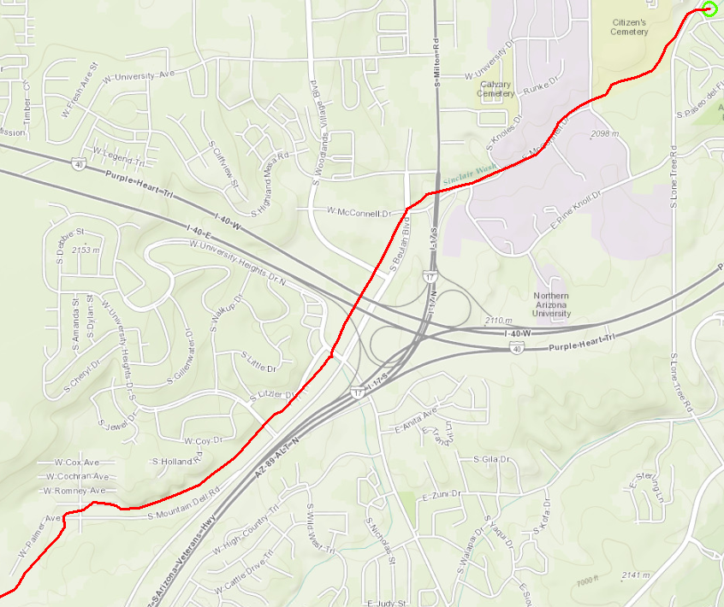
Walmart
Big 5
San Francisco St
University Heights Dr
1
2
3
4
5
1 Mile
City Limits
Sinclair Wash
Woody Mountain Road
N

